# User’s Manual in English Version

Yuxuan Bai(yuxuan_bai@shu.edu.cn); Qiu-An Huang(hqahqahqa@163.com)

Institute for Sustainable Energy/College of Sciences, Shanghai University, Shanghai 200444, China

## Outline

This document describes the features and the use of the EIS-Toolbox@LIB, which can be used to calculate the impedance spectra of the DFN-like impedance models. Numerical details of EIS-Toolbox@LIB are available in [1].

## 1 What is EIS-Toolbox@LIB？

### 1.1 What can EIS-Toolbox@LIB do?

Impedance models for porous electrodes can be classified into five cases: (i) Model Doyle-Fuller-Newman (DFN) [2]. Model DFN comes from the physical model, which considers the solid/electrolyte diffusion impedance and the electronic resistance of the solid phase. (ii) Model A [3]. Model DFN can be degenerated into Model A under the condition that Li+ concentration gradient of the electrolyte phase is ignored in the separator region. (iii) Model B [4]. Model A can be degenerated into Model B under the condition that Li+ concentration gradient of the electrolyte phase is ignored in the whole electrode. (iv) Model C [5]. Model B can be degenerated into Model C under the condition that the electrical resistance of the solid phase is ignored in the whole electrode. (v) Others (Models D–F) [6–8]. If the solid diffusion impedance is ignored in Models A–C, Models D–F can be obtained, respectively. In the present work, Model DFN and Models A–F as the DFN-like impedance models are considered.

The main feature of EIS-Toolbox@LIB is an accurate and computationally efficient simulation of the DFN-like impedance models [2–8] based on the implementation and results presented in [1]. These results have been summarized in Table 1.

**Table 1**. EIS-Toolbox@LIB based on the unified impedance model.

|  |  |
| --- | --- |
| **Calculation** | **Description** |
| *Z*1, *Z*2, *Z*3 | Model DFN has no extra simplifications |
| *z*d, *z*F, *z*int | The single particle model has three scales |
| *Z*A#1, *Z*A#2, *Z*A#3 | Model A ignores the diffusion impedance of the pore electrolyte in the separator based on Model DFN |
| *Z*B#1, *Z*B#2, *Z*B#3 | Model B ignores the diffusion impedance of the pore electrolyte in the electrode based on Model A |
| *Z*C#1, *Z*C#2, *Z*C#3 | Model C ignores the electronic resistance of the solid phase in the electrode based on Model B |
| *Z*D#1, *Z*D#2, *Z*D#3 | Model D ignores the diffusion impedance of the solid phase in the electrode based on Model A |
| *Z*E#1, *Z*E#2, *Z*E#3 | Model E ignores the diffusion impedance of the solid phase in the electrode based on Model B |
| *Z*F#1, *Z*F#2, *Z*F#3 | Model F ignores the diffusion impedance of the solid phase in the electrode based on Model C |
| *Z*Ds, *Z*De | The solid and electrolyte diffusion impedance |

### 1.2 How many sub-functions in EIS-Toolbox@LIB？

In detail, EIS-Toolbox@LIB mainly consists of 11 sub-functions, i.e., EIS.m, Extract_Re_Im.m, Model_A_D_calculate.m, Model_B_E_calculate.m, Model_C_F_calculate.m, Model_DFN_calculate.m, Model_Diffusion_calculate.m, Model_Particle_calculate.m, Parameter_initialize.m, Parameter_update.m, and Sensitivity_calculate.m.

#### (1) EIS.m

EIS calculates the impedance of DFN-like impedance models for Li-ion batteries.

Inputs:

- p is a MATLAB struct containing the initial parameters and the calculated extra parameters.

- f is frequency, Hz.

Outputs:

- out is a MATLAB struct containing the simulation parameters (p), frequency (*f* & *f*ZD), the particle impedance (*z*d, *z*F, & *z*int), the impedance of individual components in the full cell (*Z*, *Z*A#, *Z*B#, *Z*C#, *Z*D#, *Z*E#, *Z*F#), and the diffusion impedance (*Z*Ds, *Z*De, & *Z*D).

#### (2) Extract_Re_Im.m

Extract_Re_Im extracts the real and imaginary parts of the complex impedance.

Inputs:

- z is a MATLAB struct containing the particle complex impedance in the single particle model.

- Z is a MATLAB struct containing the complex impedance of individual components in the full cell.

- ZD is a MATLAB struct containing the diffusion complex impedance for Li-ion batteries.

Outputs:

- z is a MATLAB struct containing the particle complex impedance and its real & imaginary parts.

- Z is a MATLAB struct containing the complex impedance of individual components and its real & imaginary parts.

- ZD is a MATLAB struct containing the diffusion complex impedance and its real & imaginary parts.

#### (3) Model_A_D_calculate.m

Model_A_D_calculate calculates the impedance of Model A or D for Li-ion batteries.

Inputs:

- p is a MATLAB struct containing the initial parameters and the calculated extra parameters.

- w is a MATLAB struct containing the frequency variable *s* = j*2*π\**f* and the calculated related variables.

- z is a MATLAB struct containing three particle impedances in the single particle model, such as solid-diffusion impedance *z*d, the faradaic behavior impedance *z*F, and the interfacial impedance *z*int.

Outputs:

- Var is a MATLAB struct containing all internal cell electrochemical variables, such as electrolyte concentration *C*e(*x*,*s*), solid-electrolyte potential difference *Φ*s-e(*x*,*s*), reaction flux *J*(*x*,*s*), solid particle surface concentration *C*ss(*x*,*s*), solid potential *Φ*s(*x*,*s*), and electrolyte variables *Φ*e(*x*,*s*).

- Z is a MATLAB struct containing the impedance of individual components in the full cell, such as the negative electrode impedance *Z*A#1(*s*) or *Z*D#1(*s*), the positive electrode impedance *Z*A#2(*s*) or *Z*D#2(*s*), the separator impedance *Z*A#3(*s*) or *Z*D#3(*s*), and the full cell impedance *Z*A#4(*s*) or *Z*D#4(*s*).

#### (4) Model_B_E_calculate.m

Model_B_E_calculate calculates the impedance of Model B or E for Li-ion batteries.

Inputs:

- p is a MATLAB struct containing the initial parameters and the calculated extra parameters.

- w is a MATLAB struct containing the frequency variable *s* = j*2*π\**f* and the calculated related variables.

- z is a MATLAB struct containing three particle impedances in the single particle model, such as solid-diffusion impedance *z*d, the faradaic behavior impedance *z*F, and the interfacial impedance *z*int.

Outputs:

- Var is a MATLAB struct containing all internal cell electrochemical variables, such as electrolyte concentration *C*e(*x*,*s*), solid-electrolyte potential difference *Φ*s-e(*x*,*s*), reaction flux *J*(*x*,*s*), solid particle surface concentration *C*ss(*x*,*s*), solid potential *Φ*s(*x*,*s*), and electrolyte variables *Φ*e(*x*,*s*).

- Z is a MATLAB struct containing the impedance of individual components in the full cell, such as the negative electrode impedance *Z*B#1(*s*) or *Z*E#1(*s*), the positive electrode impedance *Z*B#2(*s*) or *Z*E#2(*s*), the separator impedance *Z*B#3(*s*) or *Z*E#3(*s*), and the full cell impedance *Z*B#4(*s*) or *Z*E#4(*s*).

#### (5) Model_C_F_calculate.m

Model_C_F_calculate calculates the impedance of Model C or F for Li-ion batteries.

Inputs:

- p is a MATLAB struct containing the initial parameters and the calculated extra parameters.

- w is a MATLAB struct containing the frequency variable *s* = j*2*π\**f* and the calculated related variables.

- z is a MATLAB struct containing three particle impedances in the single particle model, such as solid-diffusion impedance *z*d, the faradaic behavior impedance *z*F, and the interfacial impedance *z*int.

Outputs:

- Var is a MATLAB struct containing all internal cell electrochemical variables, such as electrolyte concentration *C*e(*x*,*s*), solid-electrolyte potential difference *Φ*s-e(*x*,*s*), reaction flux *J*(*x*,*s*), solid particle surface concentration *C*ss(*x*,*s*), solid potential *Φ*s(*x*,*s*), and electrolyte variables *Φ*e(*x*,*s*).

- Z is a MATLAB struct containing the impedance of individual components in the full cell, such as the negative electrode impedance *Z*C#1(*s*) or *Z*F#1(*s*), the positive electrode impedance *Z*C#2(*s*) or *Z*F#2(*s*), the separator impedance *Z*C#3(*s*) or *Z*F#3(*s*), and the full cell impedance *Z*C#4(*s*) or *Z*F#4(*s*).

#### (6) Model_DFN_calculate.m

Model_DFN_calculate calculates the impedance of Model DFN for Li-ion batteries.

Inputs:

- p is a MATLAB struct containing the initial parameters and the calculated extra parameters.

- w is a MATLAB struct containing the frequency variable *s* = j*2*π\**f* and the calculated related variables.

- z is a MATLAB struct containing three particle impedances in the single particle model, such as solid-diffusion impedance *z*d, the faradaic behavior impedance *z*F, and the interfacial impedance *z*int.

Outputs:

- Var is a MATLAB struct containing all internal cell electrochemical variables, such as electrolyte concentration *C*e(*x*,*s*), solid-electrolyte potential difference *Φ*s-e(*x*,*s*), reaction flux *J*(*x*,*s*), solid particle surface concentration *C*ss(*x*,*s*), solid potential *Φ*s(*x*,*s*), and electrolyte variables *Φ*e(*x*,*s*).

- Z is a MATLAB struct containing the impedance of individual components in the full cell, such as the negative electrode impedance *Z*1(*s*), the positive electrode impedance *Z*2(*s*), the separator impedance *Z*3(*s*), and the full cell impedance *Z*4(*s*).

#### (7) Model_Diffusion_calculate.m

Model_diffusion_calculate calculates the diffusion impedance for Li-ion batteries.

Inputs:

- Model_DFN is a MATLAB struct containing the impedance of individual components in the Model DFN, such as the negative electrode impedance *Z*1(*s*), the positive electrode impedance *Z*2(*s*), the separator impedance *Z*3(*s*), and the full cell impedance *Z*4(*s*).

- Model_B is a MATLAB struct containing the impedance of individual components in the Model B, such as the negative electrode impedance *Z*B#1(*s*), the positive electrode impedance *Z*B#2(*s*), the separator impedance *Z*B#3(*s*), and the full cell impedance *Z*B#4(*s*).

- Model_E is a MATLAB struct containing the impedance of individual components in the Model E, such as the negative electrode impedance *Z*E#1(*s*), the positive electrode impedance *Z*E#2(*s*), the separator impedance *Z*E#3(*s*), and the full cell impedance *Z*E#4(*s*).

- f is frequency, Hz.

Outputs:

- f_ZD is frequency (*f*ZD < 1), Hz.

- ZD is a MATLAB struct containing the diffusion impedance for Li-ion batteries, such as the solid diffusion impedance *Z*Ds(*s*), the electrolyte diffusion impedance *Z*De(*s*), and the full diffusion impedance *Z*D(*s*).

#### (8) Model_Particle_calculate.m

Model_particle_calculate calculates three impedances at the particle scale.

Inputs:

- p is a MATLAB struct containing the initial parameters and the calculated extra parameters.

- f is frequency, Hz.

Outputs:

- w is a MATLAB struct containing the frequency variable *s* = j*2*π\**f* and the calculated related variables.

- z is a MATLAB struct containing three particle impedances in the single particle model, such as solid-diffusion impedance *z*d, the faradaic behavior impedance *z*F, and the interfacial impedance *z*int.

#### (9) Parameter_initialize.m

Parameters_initialize defines the parameters used in simulation.

Inputs:

- no parameters need to be passed in.

Outputs:

- p is a MATLAB struct containing the initial parameters.

#### (10) Parameter_update.m

Parameters_update calculates extra parameters.

Inputs:

- p is a MATLAB struct containing the initial parameters.

- T is the ambient temperature, K.

- SOC is the state of charge (SOC) of the full cell in the present work, dimensionless.

Outputs:

- p is a MATLAB struct containing the initial parameters and the calculated extra parameters.

#### (11) Sensitivity_calculate.m

Sensitivity_calculate calculates the relative sensitivity of the parameter X to the diffusion processes.

Inputs:

- ZD is a MATLAB struct containing the diffusion impedance for Li-ion batteries, such as the solid diffusion impedance *Z*Ds(s) or the electrolyte diffusion impedance *Z*De(s).

Outputs:

- SD is the relative sensitivity of the solid/electrolyte diffusion impedance to parameter set *X*.

### 1.3 Prerequisites

This toolbox only requires a working version of Matlab. The toolbox has been tested with Matlab R2020a but should work with any Matlab version.

## 2 How to plot figures with EIS-Toolbox@LIB？

### 2.1 Figures to be plotted

In detail, EIS-Toolbox@LIB consists of 16 main functions, i.e., Figure7_simplify_Model_A.m, Figure8_simplify_Model_B.m, Figure9_simplify_Model_C.m, Figure10_Ds_neg.m, Figure11_rs_neg.m, Figure12_k_neg.m, Figure13_rou_sei_neg.m, Figure15_L.m, Figure16_epse.m, Figure17_sigma.m, Figure19_De.m, Figure20_kappa.m, Figure21_t_plus.m, Figure23_T.m, Figure24_T_separator.m, and Main_Figure_2_5_6.m. The functions of these main functions have been summarized in Table 2. Click these .m files and run immediately without any other toolbox.

**Table 2**. The functions of main functions for EIS-Toolbox@LIB.

|  |  |
| --- | --- |
| **Main function** | **Function** |
| Figure7_simplify_Model_A | Script used to obtain impedance datas shown in Figure 7. |
| Figure8_simplify_Model_B | Script used to obtain impedance datas shown in Figure 8. |
| Figure9_simplify_Model_C | Script used to obtain impedance datas shown in Figure 9. |
| Figure10_Ds_neg | Script used to obtain impedance datas shown in Figures 10 and 14(a and b). |
| Figure11_rs_neg | Script used to obtain impedance datas shown in Figures 11 and 14(c and d). |
| Figure12_k_neg | Script used to obtain impedance datas shown in Figures 12 and 14(e and f). |
| Figure13_rou_sei_neg | Script used to obtain impedance datas shown in Figures 13 and 14(g and h). |
| Figure15_L | Script used to obtain impedance datas shown in Figures 15 and 18(a and b). |
| Figure16_epse | Script used to obtain impedance datas shown in Figures 16 and 18(c and d). |
| Figure17_sigma | Script used to obtain impedance datas shown in Figures 17 and 18(e and f). |
| Figure19_De | Script used to obtain impedance datas shown in Figures 19 and 22(a and b). |
| Figure20_kappa | Script used to obtain impedance datas shown in Figures 20 and 22(c and d). |
| Figure21_t_plus | Script used to obtain impedance datas shown in Figures 21 and 22(e and f). |
| Figure23_T | Script used to obtain impedance datas shown in Figures 23 and 25. |
| Figure24_T_separator | Script used to obtain impedance datas shown in Figures 24 and 25. |
| Main_Figure_2_5_6 | Script used to obtain impedance datas shown in Figures 2, 5, and 6. |

### 2.2 How to initialize parameters before plotting？

In the present work, graphite is chosen as the negative electrode and LiCoO2 as the positive electrode, respectively. All default parameter values required by EIS-Toolbox@LIB simulation and their physical meanings can be found in Parameter_initialize.m.

### 2.3 How to plot figures with EIS-Toolbox@LIB?

The core of EIS-Toolbox@LIB is EIS.m, the input of this sub-function is the internal parameters of the battery and simulation frequency, and the output is shown in Table 1. Fig. 1 shows the running process of key sub-functions in EIS.m. The function, input, and output of each sub-function are shown in section 1.2.

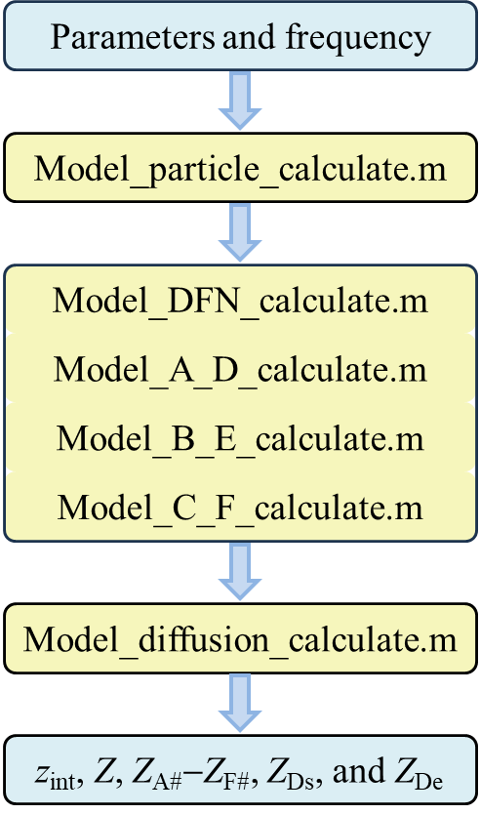

**Fig .1.** Flow chart of EIS.m.

### 2.4 Examples

The specific steps for using EIS-Toolbox@LIB are as follows:

(i) Download the EIS-Toolbox@LIB.zip file from the Supporting Information in Ref. [1] and unzip to disk D (this position can be selected by yourself);

(ii) Install and start Matlab R2020a;

(iii) Enter the command cd('D:\EIS-Toolbox@LIB') in the Command Window to modify the Current Folder, as shown in Fig. 2;

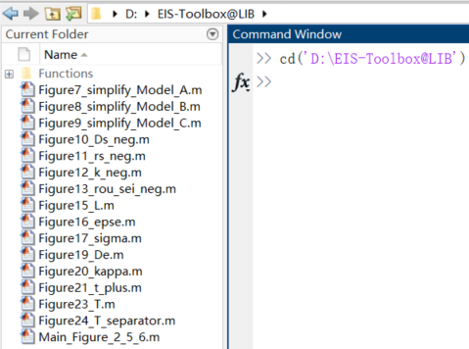

**Fig .2.** Modify the Current Folder of Matlab.

(iv) Open any .m file and click the Run button to execute this file, as shown in Fig. 3.

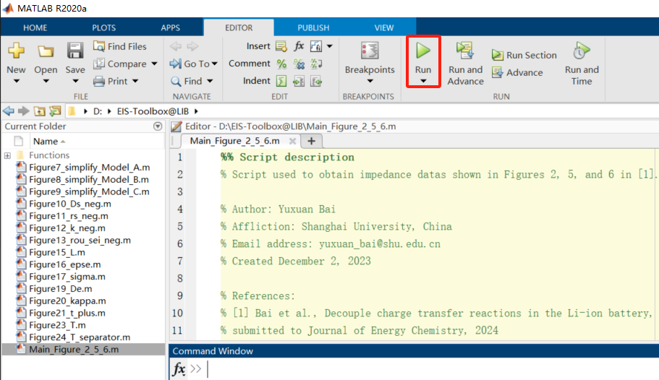

**Fig .3.** Run .m file of Matlab.

Next, specific cases are used to demonstrate the results of the toolbox.

#### (1) Simulation with default parameters

Based on the default parameters, click on the Main_Figure_2_5_6.m file, and the user can directly obtain Figs. 2, 5, and 6 in the Ref. [1]. The location of the .m file is shown in Figs. 2–3 and the corresponding simulation results are shown in Figs. 4–6.

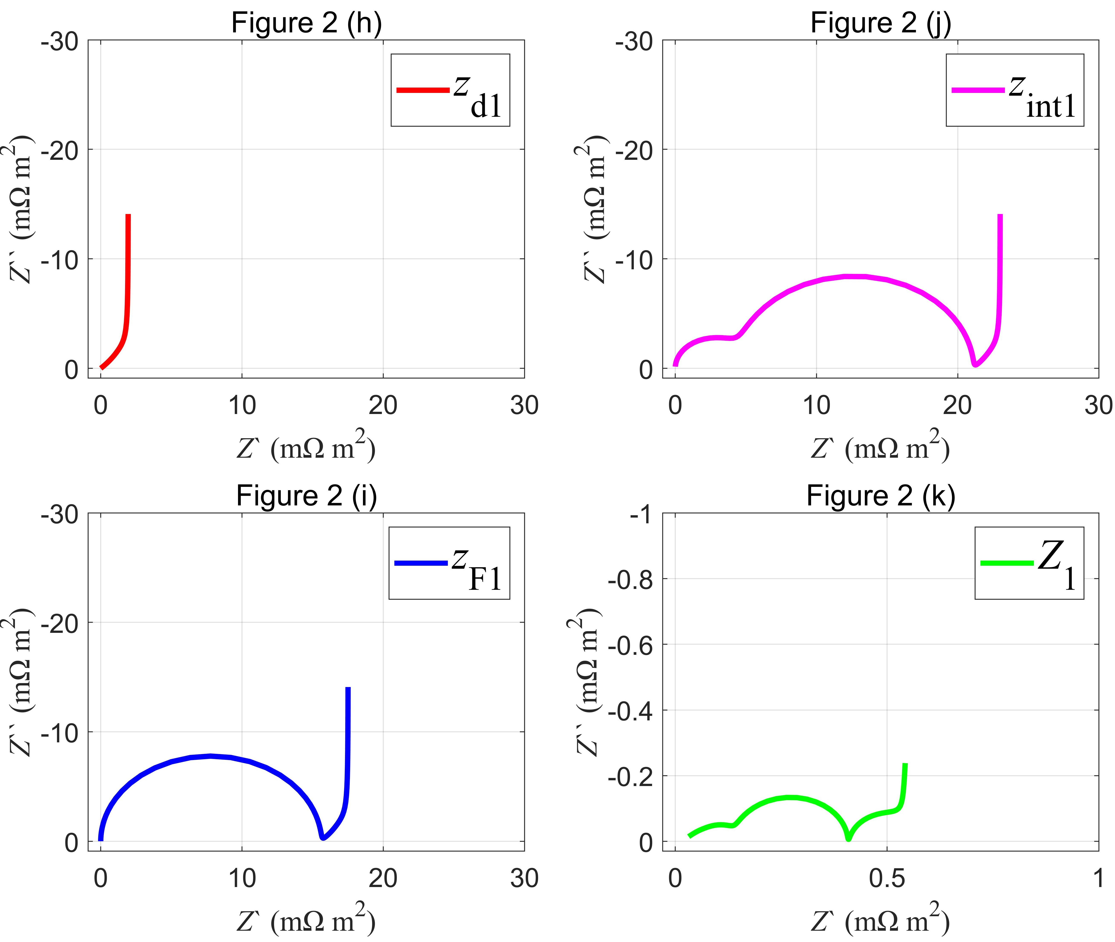

**Fig .4.** The impedance spectra for (h) *z*d1, (i) *z*F1, (j) *z*int1, and (k) *Z*1.

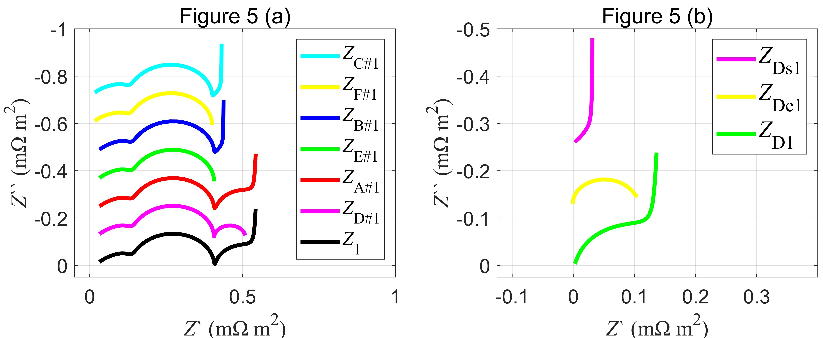

**Fig .5.** Nyquist plots of the DFN-like impedance models for the negative electrode. (a) Nyquist plots of Model DFN and Models A–F. (b) Nyquist plots of the solid/electrolyte/full diffusion impedance.

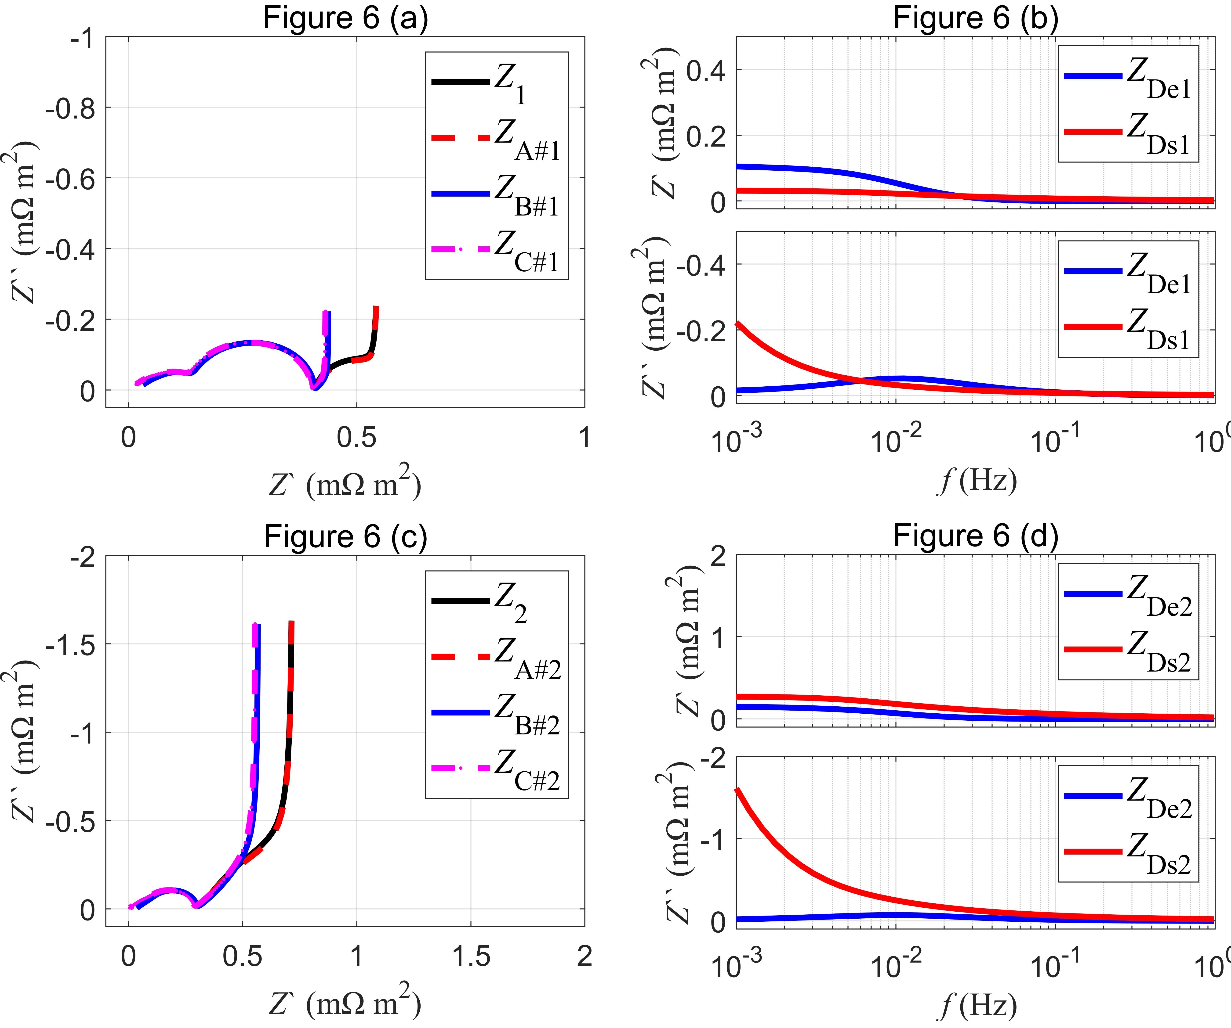

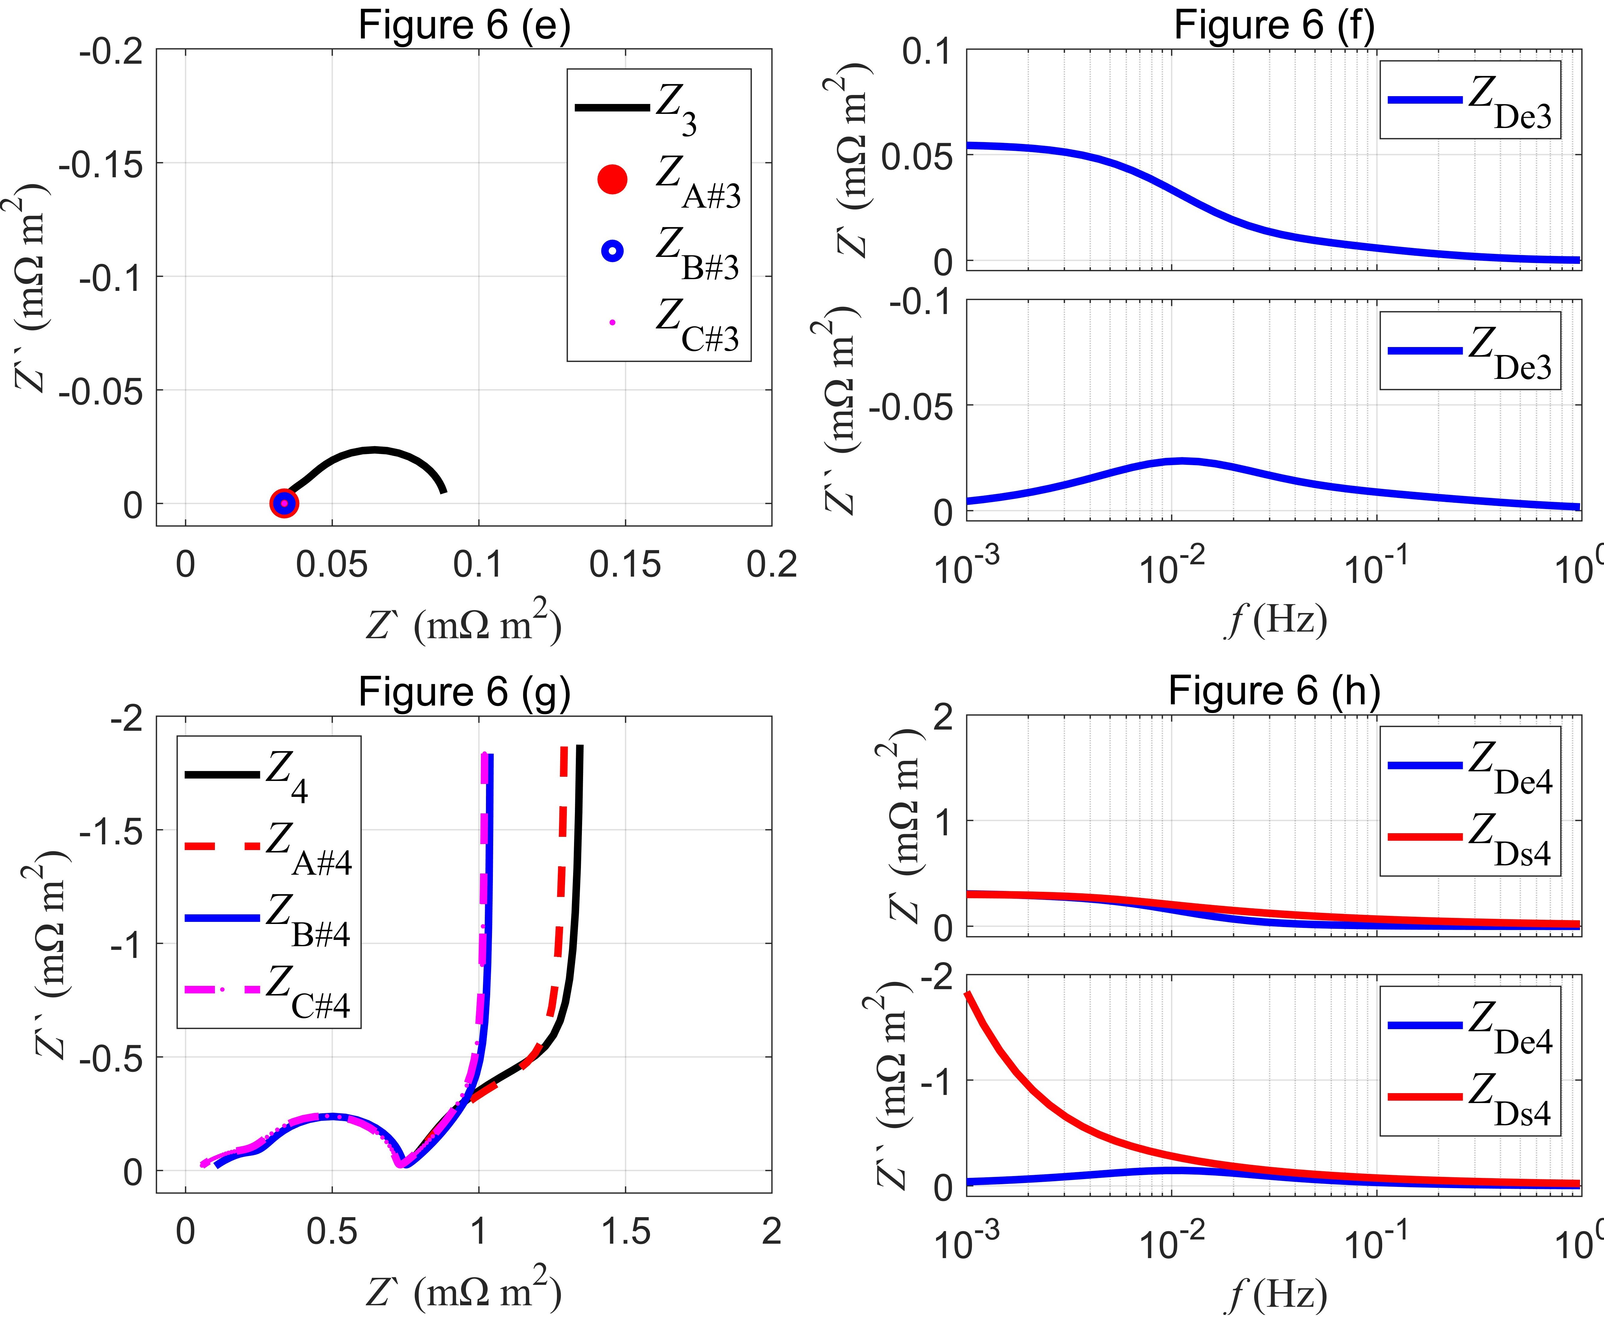

**Fig .6.** Typical characteristics of the unified impedance model for LIBs. Nyquist plots for Model DFN and Models A–C in (a, c, e, and g). Bode plots for the solid/electrolyte diffusion impedance in (b, d, f, and h).

#### (2) Simulation with modified parameters

By modifying the parameters, the user can obtain Figs. 7–25 in the Ref. [1]. The user can directly obtain Fig. 7 by clicking on the Figure7_simplify_Model_A.m file, and the corresponding simulation results are shown in Fig. 7. The remaining figures and their corresponding code names are shown in Table 2.

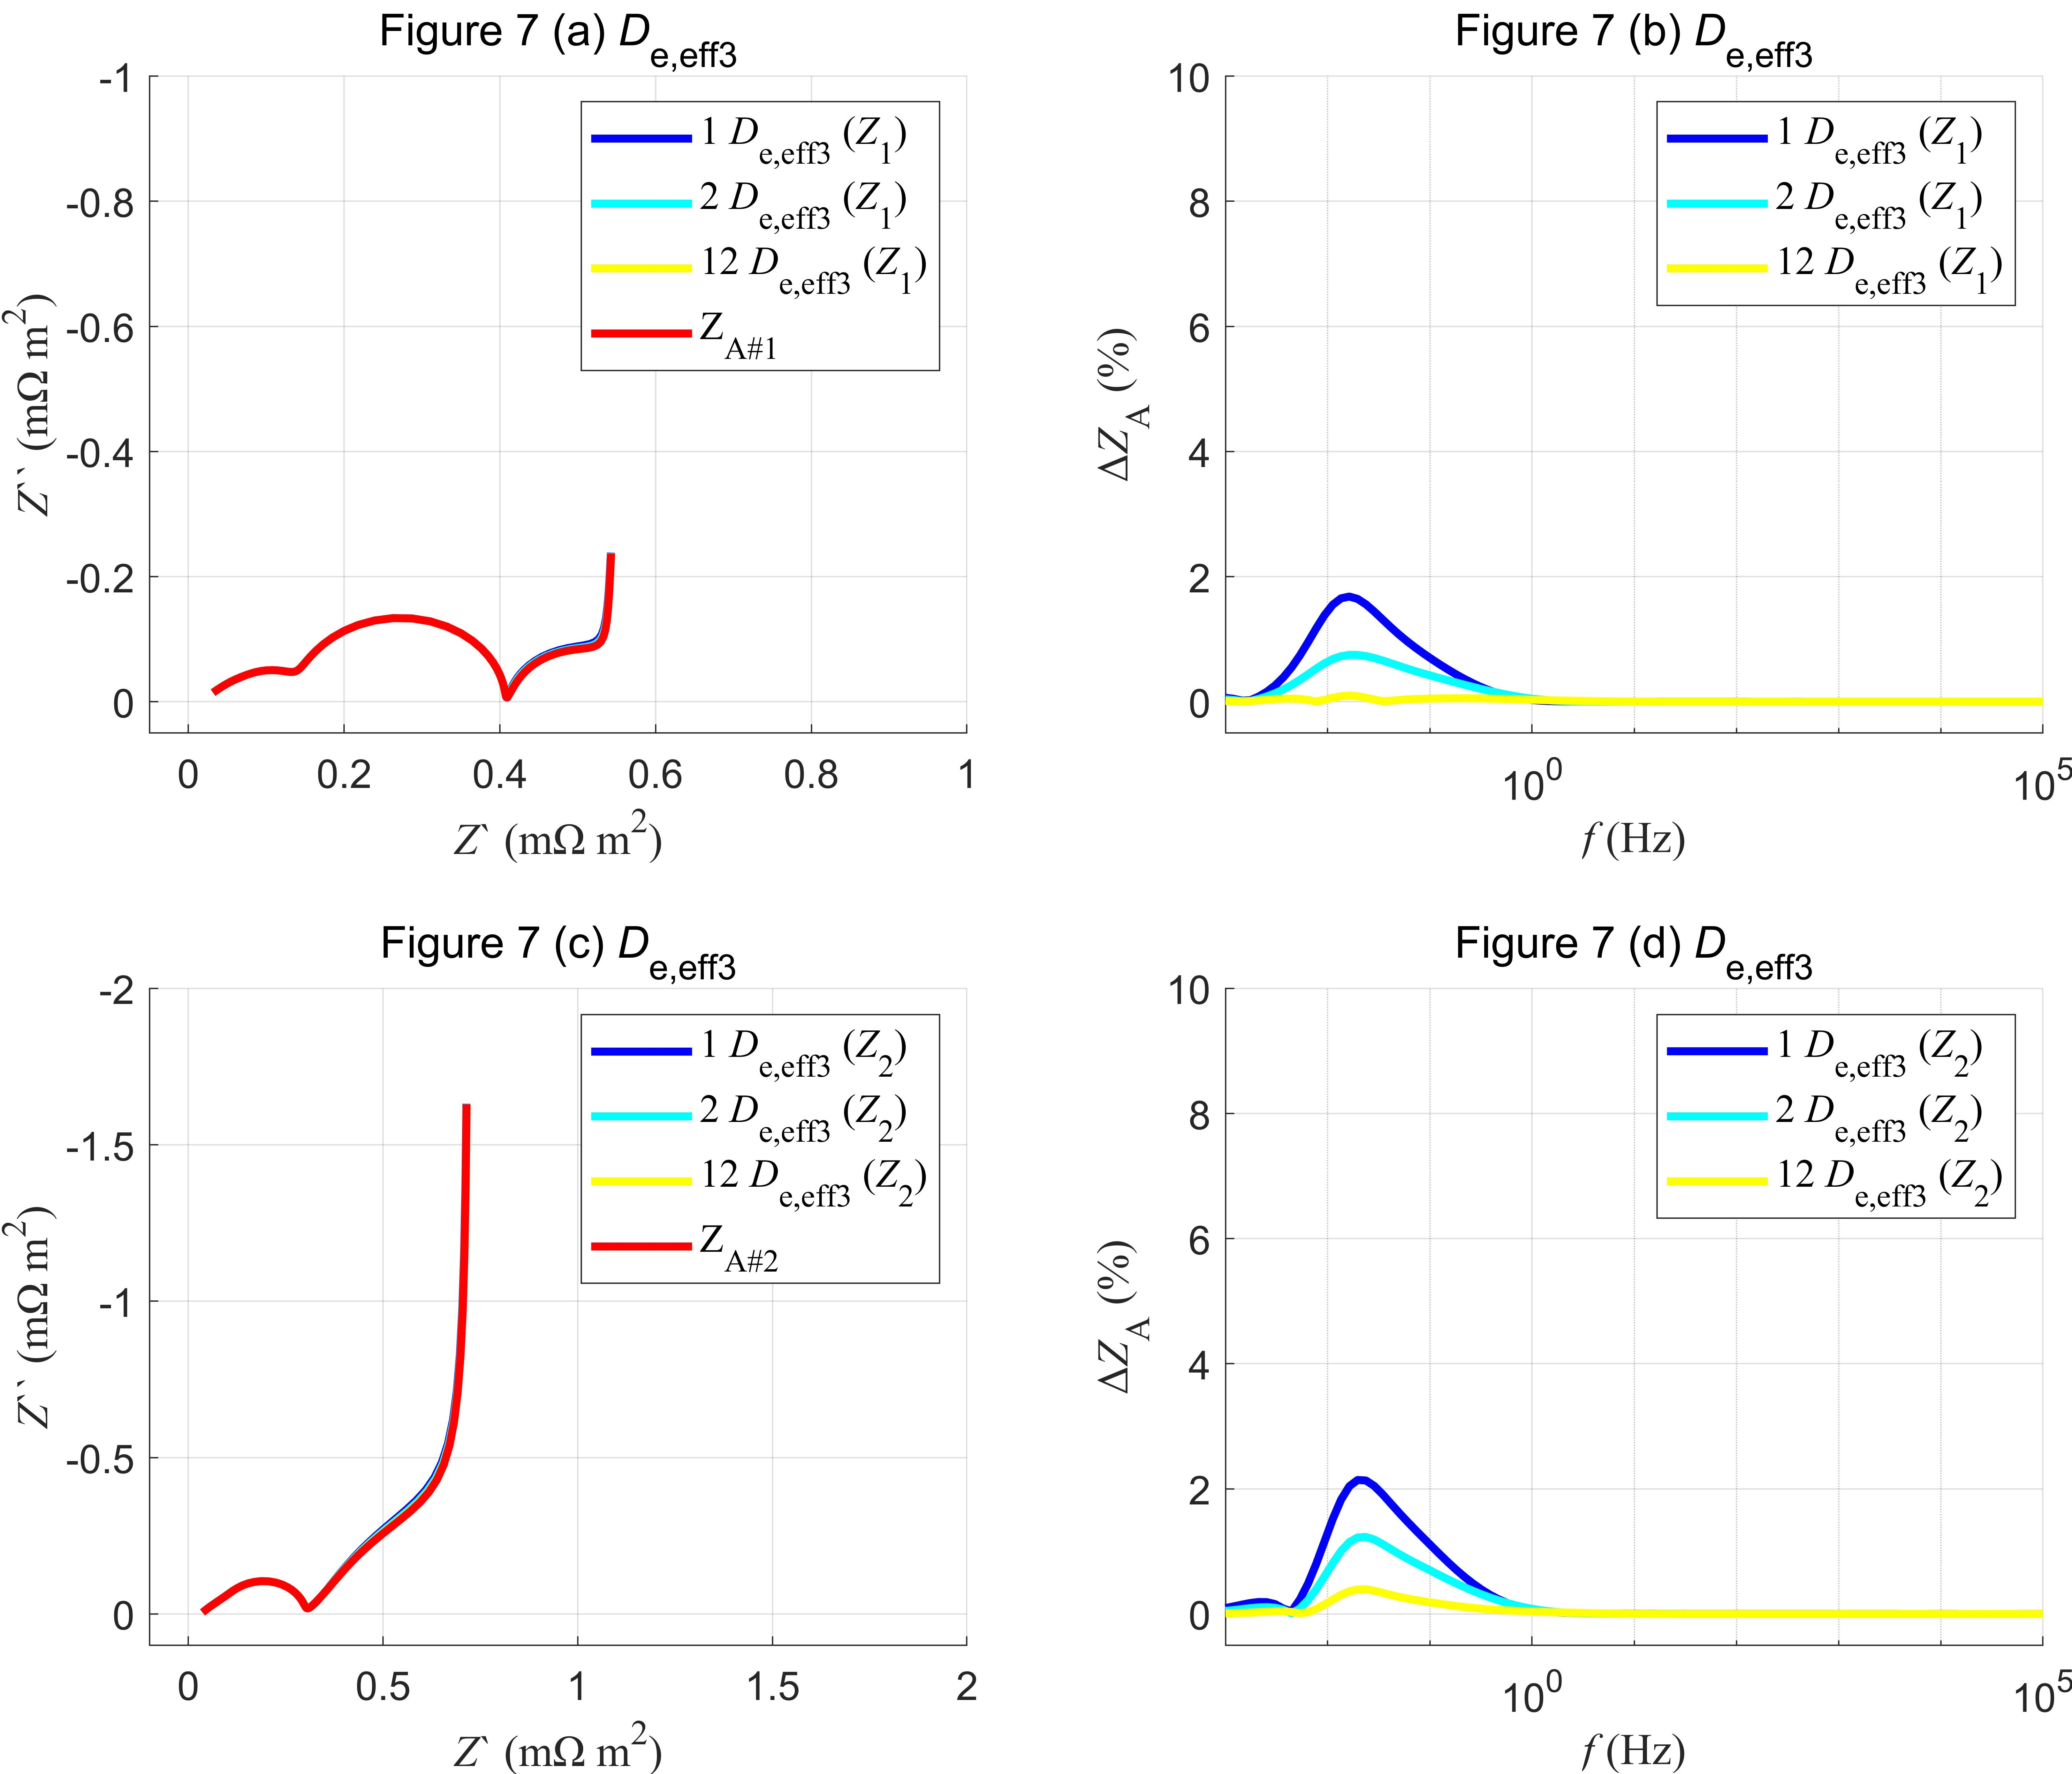

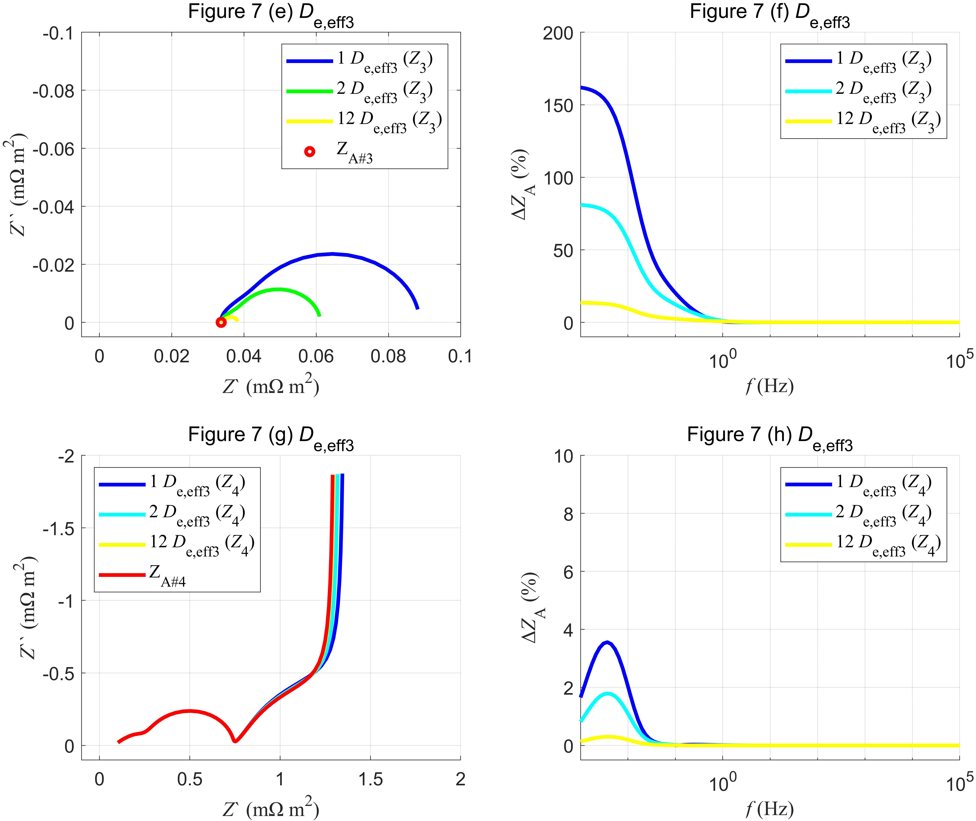

**Fig. 7.** Degeneration and relative differences for Model DFN toward Model A with increasing *D*e,eff3 in the separator.

## 3. References

[1] Y. Bai, Q.-A. Huang, K. Wu, J. Zhang, Decouple charge transfer reactions in the Li-ion battery, Journal of Energy Chemistry, 2024.

[2] G. Sikha, R.E. White, Analytical expression for the impedance response for a lithium-ion cell, J. Electrochem. Soc. 155 (2008) A893–A902.

[3] J. Huang, J. Zhang, Theory of impedance response of porous electrodes: simplifications, inhomogeneities, non-stationarities and applications, J. Electrochem. Soc. 163 (2016) A1983–A2000.

[4] J.P. Meyers, M. Doyle, R.M. Darling, J. Newman, The impedance response of a porous electrode composed of intercalation particles, J. Electrochem. Soc. 147 (2000) 2930–2940.

[5] M. Cronau, M. Kroll, M. Szabo, F. Sälzer, B. Roling, Thickness-dependent impedance of composite battery electrodes containing ionic liquid-based electrolytes, Batteries Supercaps. 3 (2020) 611–618.

[6] S. Devan, V.R. Subramanian, R.E. White, Analytical solution for the impedance of a porous electrode, J. Electrochem. Soc. 151 (2004) A905–A913.

[7] G. Paasch, K. Micka, P. Gersdorf, Theory of the electrochemical impedance of macrohomogeneous porous electrodes, Electrochim. Acta. 38 (1993) 2653–2662.

[8] R. De Levie, On porous electrodes in electrolyte solutions—IV, Electrochim. Acta. 9 (1964) 1231–1245.